DECLARATION

I hereby declare that the project work presented is originally done by me under the guidance of **Dr.** **D.SURESH KUMAR M.Sc.,M.Phil.,Ph.D.,M.Tech(IT) Assistant Professor, PG Department of Computer Science (S.F), Bishop Heber College (Autonomous), Tiruchirappalli-620 017** and has not been included in any other thesis/project submitted for any other degree.

Name of the Candidate : C.VANI SRI

Register Number : 195114636

Batch : 2019-2022

Signature of the Candidate

**Dr.** **D.SURESH KUMAR M.Sc.,M.Phil.,Ph.D.,M.Tech(IT)**

**Assistant Professor,**

PG Department of Computer Science (S.F),

Bishop Heber College (Autonomous),

Tiruchirappalli – 620017

**Date:**

**CERTIFICATE**

This is to certify that the project work entitled “TIMETABLE GENERATION WITH ACCESS OVER COLLEGE”is a bonafide record work done by C. VANI SRI, 195114636 in partial fulfillment of the requirements for the award of the degree of BACHELOR OF SCIENCE IN COMPUTER SCIENCE during the period 2019-2022.

**Place: Signature of the Guide**

**PG DEPARTMENT OF COMPUTER SCIENCE (S.F)**

BISHOP HEBER COLLEGE (AUTONOMOUS),

(Nationally Reaccredited at the ‘A’ Grade by NAAC with the CGPA of 3.58 out of 4)

(Recognized by UGC as “College of Excellence”)

(Affiliated to Bharathidasan University)

TIRUCHIRAPPALLI - 620017

Date:

Course Title: Project Course Code: U18CS6PJ

CERTIFICATE

The Viva-Voce examination for the candidate C.VANI SRI, 195114636 was held on _________________.

Signature of the HOD Signature of the Guide

Examiners:

1.

2.

**ACKNOWLEDGEMENT**

First, I am very thankful to the almighty for showering the Blessings throughout my life. I would like to express my heartfelt thanks to my beloved parents who have sacrificed a lot for my future. This support was the foundation stone for my efforts.

I acknowledge my sincere thanks **to Dr. D. PAUL DHAYABARAN, M.Sc., M.Phil., PGDCA., Ph.D.,** Principal, Bishop Heber College (Autonomous), Tiruchirappalli, for giving me the opportunity to do my Undergraduate Degree course in the renowned institution and providing facilities to carry out the project work.

I submit my heartfelt thanks to **Dr. J.G.R. SATHIASEELAN, M.Sc., Ph.D.,** Associate Professor**,** Co-ordinate of Computer Science, IT & CA, Bishop Heber College, Tiruchirappalli, for his guidance and support in successful completion of the project work.

I am very proud and thankful to **Dr. G. SOBERS SMILES DAVID M.C.A., M.Phil.,**

**NET., Ph.D.,** Associate Professor and Head, Department of Computer Science, Bishop Heber College, Tiruchirappalli, for giving me the opportunity to do the course in the college.

I am grateful to **Dr.** **D.SURESH KUMAR M.Sc.,M.Phil.,Ph.D.,M.Tech(IT)** , Associate Professor ,Department of Computer Science (S.F), Department of Computer Science (S.F), Bishop Heber College (Autonomous), Tiruchirappalli, the internal guide for timely suggestions and constant encouragement and support that led to the accomplishment of the project.

I extended my thanks to all faculty members of Department of Computer Science for their support and motivation towards my entire journey of my course.

I wish to express my heartfelt thanks to my friends for their continuous encouragement and assistance right from the beginning to the end of the journey of my project.

**C.VANI SRI**

**ABSTRACT**

Time table generation is tedious job for educationalist with respect to time and man power. Providing a automatic time table generator will help to generate time table automatically. Proposed system of our project will help to generate it automatically also helps to save time. It avoids the complexity of setting and managing Timetable manually. In our project we are going to use algorithms like genetic, heuristic, resource scheduling to reduce these difficulties of generating timetable. These systems incorporate a numeral of strategy, aimed to improve the cooperativeness of the search operation. The system will take various inputs like number of subjects, teachers, and workload of a teacher, semester, and priority of subject. By relying on these inputs, it will generate possible time tables for working days of the week for teaching faculty. This will integrate by making optimal use of all resources in a way that will best suit the constraints.

**TABLE OF CONTENTS**

|  |  |  |
| --- | --- | --- |
| **CHAPTERS** | **TITLE** | **PAGE NO.** |
|  | **Certificates Acknowledgments**  **Abstract** |  |
| **CHAPTER I** | **Project Description**  1.1. Introduction  1.2 Existing System  1.3 Proposed System | 1  2  3 |
| **CHAPTER II** | **Logical Development**  2.1. DFDs  2.2. Architectural Design | 7  8 |
| **CHAPTER III** | **Database design**  3.1. Data Dictionary  3.2. Tables Design  3.3. Relationship Diagram | 10  11  13 |
| **CHAPTER IV** | **Program Design**  (Logic / Working of the various Programs (or) modules in detail) | 15 |
| **CHAPTER V** | **Testing**  (What testing you have applied) Validation Screens Justify | 17 |
| **CHAPTER VI** | **Conclusion** | 22 |
| **CHAPTER VII** | **References** | 23 |
| **CHAPTER VIII** | **Appendix**  8.1. Source Code  8.2. O/P Screens | 24  82 |

**CHAPTER I**

1. **PROJECT DESCRIPTION**

**1.1 INTRODUCTION**

Even though most college administrative work has been computerized, the lecture timetable scheduling is still mostly done manually due to its inherent difficulties. The manual lecture timetable scheduling demands considerable time and efforts. The lecture-timetable scheduling is a Constraint satisfaction problem in which we find a solution that satisfies the given set of constraints. A college timetable is a temporal arrangement of a set of lectures and classrooms in which all given constraints are satisfied. Creating such timetables manually is a complex and time-consuming process. By automating this process with computer assisted timetable generator can save a lot of precious time of administrators who are involved in creating and managing course timetables. Time table generation is tedious job for educationalist with respect to time and man power. Providing a automatic time table generator will help to generate time table automatically. Proposed system of our project will help to generate it automatically also helps to save time. It avoids the complexity of setting and managing Timetable manually. In our project we are going to use algorithms like genetic, heuristic, resource scheduling to reduce these difficulties of generating timetable. These algorithms incorporate a numeral of strategy, aimed to improve the cooperativeness of the search operation. The system will take various inputs like number of subjects, teachers, and workload of a teacher, semester, and priority of subject. By relying on these inputs, it will generate possible time tables for working days of the week for teaching faculty. This will integrate by making optimal use of all resources in a way that will best suit the developed system.

**1.2 EXISTING SYSTEM**

Through the analysis and the summarization of the existing problems, a mathematical model for the course timetable system is proposed. At the same time, through the use of the pattern recognition technology in artificial intelligence, aiming at this mathematical model a new university course timetable system design program is proposed and realized. This program not only can well solve the shortages of the existing course timetable system, but also is simple and easy to operate, has strong versatility. evolutionary techniques have been used to solve the time table scheduling problem. Methodologies like Genetic Algorithms (GAs), Evolutionary Algorithms (EAs) etc have been used with mixed success. In this paper, we have reviewed the problem of educational time table scheduling and solving it with genetic algorithm.

**1.3 PROPOSED SYSTEM**

Our Timetabling Algorithm is main component of our project which produces he HTML based timetable even / odd semester sheet as the output. Our project takes various inputs from the user such as Teacher List, Course List, Semester List, Room List, Day List and Timeslot as well as various rules, facts and constraints using web based forms, which are stored in XML based knowledge base. This knowledge base serves as input to our Timetable Generator Algorithm residing on server machine. Our knowledgebase is in the middle, because it is between our timetabling algorithm and GUI front end which is designed in the last. After the representation of KB is standardized, we designed the timetabling algorithm. The design of timetabling algorithm took most of our total time. During design of algorithm, first problem was, from where to start? Second problem was, does it really going to work? But after all due to our superior design of knowledgebase, flowcharts and enough thinking on timetabling data structure representation helped us to really boosted building our fine working algorithm.

**CHAPTER II**

**2. LOGICAL DEVELOPMENT**

**2.1. DFDs**

A two-dimensional diagram explains how data is processed and transferred in a system. The graphical depiction identifies each source of data and how it interacts with other data sources to reach a common output. Individuals seeking to draft a data flow diagram must identify external inputs and outputs, determine how the inputs and outputs relate to each other, and explain with graphics how these connections relate and what they result in. This type of diagram helps business development and design teams visualize how data is processed and identify or improve certain aspects.

**Data flow Symbols:**

|  |  |
| --- | --- |
| **Symbol** | **Description** |
| http://cpanel.stpaulsscience.org/gceict/specifications/ocr/unit3/sdlc/dfd/entity.jpg | An **entity**. A source of data or a destination for data. |
| http://cpanel.stpaulsscience.org/gceict/specifications/ocr/unit3/sdlc/dfd/process.jpg | A **process** or task that is performed by the system. |
| http://cpanel.stpaulsscience.org/gceict/specifications/ocr/unit3/sdlc/dfd/store.jpg | A **data store**, a place where data is held between processes. |
| http://cpanel.stpaulsscience.org/gceict/specifications/ocr/unit3/sdlc/dfd/flow.jpg | A **data flow**. |

**LEVEL 0**

DFD Level 0 is also called a Context Diagram. It’s a basic overview of the whole system or process being analyzed or modeled. It’s designed to be an at-a-glance view, showing the system as a single high-level process, with its relationship to external entities. It should be easily understood by a wide audience, including stakeholders, business analysts, data analysts and developers.

Admin

Staff

Database

Student

**Fig Level O DFDS Diagram**

**LEVEL 1**

DFD Level 1 provides a more detailed breakout of pieces of the Context Level Diagram. You will highlight the main functions carried out by the system, as you break down the high-level process of the Context Diagram into its sub – processes. A level 1 data flow diagram (DFD) is more detailed than a level 0 DFD but not as detailed as a level 2 DFD. It breaks down the main processes into sub processes that can then be analyzed and improved on a more intimate level.

Admin

Staff

Student

**Fig Level 1 DFDS Diagram**

**2.2. ARCHITECTURAL DESIGN**

A system architecture or systems architecture is the conceptual model that defines the structure, behavior, and more views of a system. An architecture description is a formal description and representation of a system, organized in a way that supports reasoning about the structures and behaviors of the system. System architecture can comprise system components, the externally visible properties of those components, the relationships (e.g. the behavior) between them. It can provide a plan from which products can be procured, and systems developed, that will work together to implement the overall system. There have been efforts to formalize languages to describe system architecture; collectively these are called architecture description languages (ADLs).

**Various organizations define systems architecture in different ways, including:**

* An allocated arrangement of physical elements which provides the design solution for a consumer product or life-cycle process intended to satisfy the requirements of the functional architecture and the requirements baseline.
* Architecture comprises the most important, pervasive, top-level, strategic inventions, decisions, and their associated rationales about the overall structure (i.e., essential elements and their relationships) and associated characteristics and behavior.
* If documented, it may include information such as a detailed inventory of current hardware, software and networking capabilities; a description of long-range plans and priorities for future purchases, and a plan for upgrading and/or replacing dated equipment and software.

An architecture diagram is a graphical representation of a set of concepts that are part of architecture, including their principles, elements and components. Architecture diagram can help system designers and developers visualize the high-level, overall structure of their system or application, in order to ensure the system meets their users' needs. Using architecture diagram, you can also describe patterns that are used throughout the design. It's somewhat like a blueprint that you use as a guide, so that you and your colleagues can discuss, improve and follow.

Register

Login

Time Table Department

Logout

Login

Add Staff

Allot Time Table

Timetable Depart

Logout

**TIME TABLE GENERATION WITH ACCESS OVER COLLEGE**

Admin

Register

Login

department

Department Time Table

Logout

Student

Register

Login

View Allotment

Logout

Staff

Register

Login

Choose department

View time table

Logout

**Fig 2.2 Architecture Design**

**CHAPTER III**

**3. DATABASE DESIGN**

**3.1. Data Dictionary**

|  |  |  |
| --- | --- | --- |
| **Field** | **Description** | **Example** |
| Una*me | admin username | Admin |
| password | admin password | Admin |
| dept | Dept | Cs |
| semester | Semester | 3 rd |
| day1 | day1 | Eng |
| day2 | day2 | Maths |
| day3 | day3 | Maths |
| day4 | day4 | maths 2 |
| day5 | day5 | Science |
| day6 | day6 | Evs |
| dept | Dept | Cs |
| semester | Semester | 3 rd |
| day1 | day1 | Eng |
| day2 | day2 | Maths |
| Name | Name | Jana |
| RollNo | RollNo | 102 |
| DepartMent | DepartMent | Cs |
| EmailId | EmailId | [jana@gmail.com](mailto:jana@gmail.com) |
| MobileNumber | MobileNumber | 9558447996 |
| Address | Address | Trichy |
| Name | Name | Jana |
| RollNo | RollNo | 102 |
| DepartMent | DepartMent | Cs |

**3.2. Tables Design**

**Admin**

|  |  |  |  |
| --- | --- | --- | --- |
| **Field** | **Type** | **Null** | **Default** |
| Id | varchar(100) | Yes | NULL |
| UserName | varchar(100) | Yes | NULL |
| Password | varchar(100) | Yes | NULL |

**Time table**

|  |  |  |  |
| --- | --- | --- | --- |
| **Field** | **Type** | **Null** | **Default** |
| Id | int(100) | Yes | NULL |
| dept | varchar(100) | Yes | NULL |
| semester | varchar(100) | Yes | NULL |
| day1 | varchar(100) | Yes | NULL |
| day2 | varchar(100) | Yes | NULL |
| day3 | varchar(100) | Yes | NULL |
| day4 | varchar(100) | Yes | NULL |
| day5 | varchar(100) | Yes | NULL |
| day6 | varchar(100) | Yes | NULL |

**User register**

|  |  |  |  |
| --- | --- | --- | --- |
| **Field** | **Type** | **Null** | **Default** |
| Id | varchar(100) | Yes | NULL |
| Name | varchar(100) | Yes | NULL |
| RollNo | varchar(100) | Yes | NULL |
| DepartMent | varchar(100) | Yes | NULL |
| EmailId | varchar(100) | Yes | NULL |
| MobileNumber | varchar(100) | Yes | NULL |
| Address | varchar(100) | Yes | NULL |
| UserName | varchar(100) | Yes | NULL |
| Password | varchar(100) | Yes | NULL |

**3.3. RELATIONSHIP DIAGRAM**

An entity–relationship model (ER model for short) describes interrelated things of interest in a specific domain of knowledge. A basic ER model is composed of entity types (which classify the things of interest) and specifies relationships that can exist between [entities](https://en.wikipedia.org/wiki/Entity) (instances of those entity types). In [software engineering](https://en.wikipedia.org/wiki/Software_engineering), an ER model is commonly formed to represent things a business needs to remember in order to perform business processes. Consequently, the ER model becomes an abstract [data model](https://en.wikipedia.org/wiki/Data_modeling) that defines data or information structure which can be implemented in a [database](https://en.wikipedia.org/wiki/Database), typically a [relational database](https://en.wikipedia.org/wiki/Relational_database)

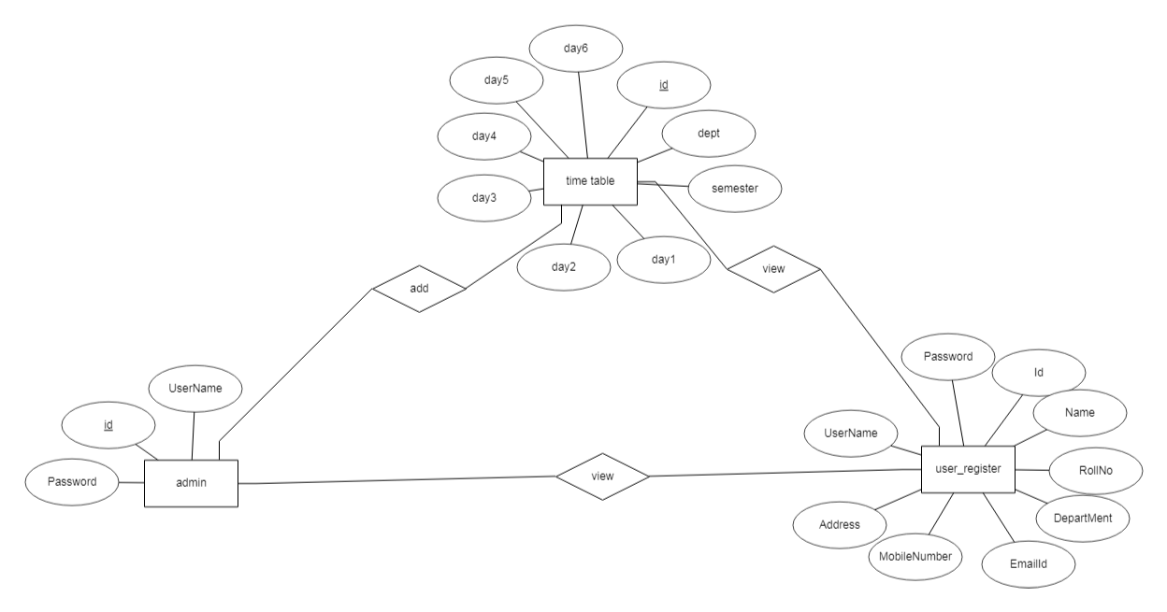

**Fig 3.3 relationship diagram**

**CHAPTER IV**

**4. PROGRAM DESIGN**

This application offers easier slot assigning for generating the time table. This application requires less time for consumption. No slot clashes. Always considers the other department slots first. Various possible slot combinations can be acquired. User friendly to the admin, staff and students.

The project has the following main modules,

* Admin
* Staff
* Student

**Modules Description**

**ADMIN**

**Login**

In login session admin has a separate username and password session where they will login and manage the staff and the student, admin will generate the time table for the particular staff and students.

**Add Staff**

Admin will be adding staff in this module. It contains staff id, staff name, department, class, qualification, contact, email id.

**Allot Time Table**

Admin only allot the time table for staff and students. It contains the fields like Days, Time and hour, subject, staff name, class details. The admin will generate the time table to the staff and student for the particular class or semester. The admin will get the subject details and timing of the staff.

**Time Table Department**

Admin will be adding the timetable department in this module. It contains staff details, subject, hour details**.**

**STAFF**

**Register and Login**

Staff had to register and get a separate login session where they have to produce the data to be uploaded by the staff.

**View Allot Time Table**

Staff can view the allotment after login this module. It shows the time table scheduling for Staff. After selecting the class they can view the timetable of the class

**STUDENT**

**Registration**

Student had to register with their details to write online test and so on with their registered process. They will be provided with a username and password.

**Student Login**

Student will be provided with a separate login session so that they have to login with their username and password to know the details and download the documents uploaded.

**Department Time Table**

Student can view the department time table in this module. It contains staff details, subject, hour details.

**CHAPTER V**

**5. TESTING**

**TESTING**

Testing is a series of different tests that whose primary purpose is to fully exercise the computer based system. Although each test has a different purpose, all work should verify that all system element have been properly integrated and performed allocated function. Testing is the process of checking whether the developed system works according to the actual requirement and objectives of the system. The philosophy behind testing is to find the errors. A good test is one that has a high probability of finding an undiscovered error. A successful test is one that uncovers the undiscovered error. Test cases are devised with this purpose in mind. A test case is a set of data that the system will process as an input.

**SYSTEM TESTING**

After a system has been verified, it needs to be thoroughly tested to ensure that every component of the system is performing in accordance with the specific requirements and that it is operating as it should including when the wrong functions are requested or the wrong data is introduced.

Testing measures consist of developing a set of test criteria either for the entire system or for specific hardware, software and communications components. For an important and sensitive system such as an electronic voting system, a structured system testing program may be established to ensure that all aspects of the system are thoroughly tested.

Testing measures that could be followed include:

* Applying functional tests to determine whether the test criteria have been met
* Applying qualitative assessments to determine whether the test criteria have been met.
* Conducting tests in “laboratory” conditions and conducting tests in a variety of “real life” conditions.
* Conducting tests over an extended period of time to ensure systems can perform consistently.
* Conducting “load tests”, simulating as close as possible likely conditions while using or exceeding the amounts of data that can be expected to be handled in an actual situation.

Test measures for hardware may include:

* Applying “non-operating” tests to ensure that equipment can stand up to expected levels of physical handling.
* Testing “hard wired” code in hardware (firmware) to ensure its logical correctness and that appropriate standards are followed.

Tests for software components also include:

* + - Testing all programs to ensure its logical correctness and that appropriate design, development and implementation standards have been followed.
    - Conducting “load tests”, simulating as close as possible a variety of “real life” conditions using or exceeding the amounts of data that could be expected in an actual situation.
* Verifying that integrity of data is maintained throughout its required manipulation.

**UNIT TESTING**

The first test in the development process is the unit test. The source code is normally divided into modules, which in turn are divided into smaller units called units. These units have specific behavior. The test done on these units of code is called unit test. Unit test depends upon the language on which the project is developed.

Unit tests ensure that each unique path of the project performs accurately to the documented specifications and contains clearly defined inputs and expected results. Functional and reliability test in an Engineering environment, producing tests for the behavior of components (nodes and vertices) of a product to ensure their correct behavior prior to system integration.

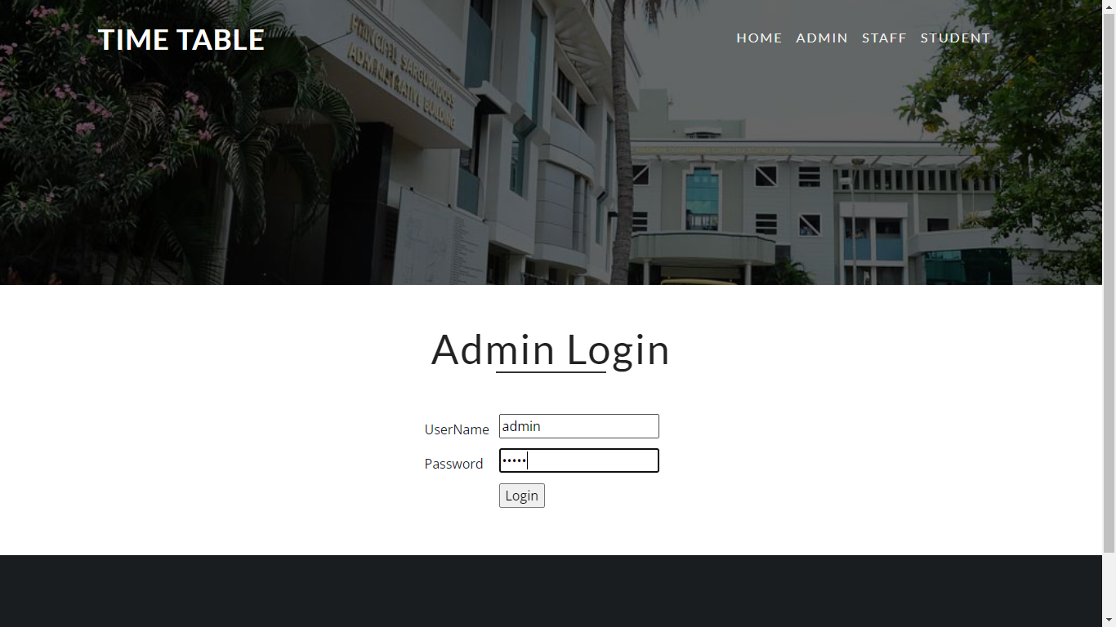

**Fig 1 Admin Login**

**Unit Testing**

**INTEGRATION TESTING**

Testing is which modules are combined and tested as a group. Modules are typically code modules, individual applications, source and destination applications on a network, etc. Integration Testing follows unit testing and precedes system testing. Testing after the product is code complete. Betas are often widely distributed or even distributed to the public at large in hopes that they will buy the final product when it is release.

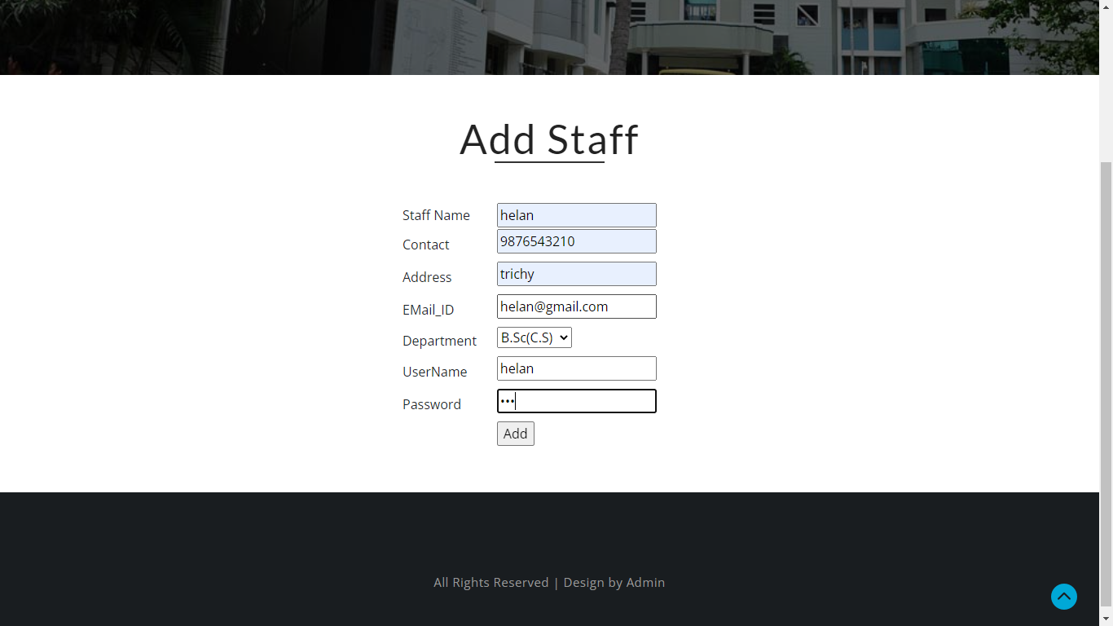

**Fig 2 Integration Testing**

**VALIDATION TESTING**

Validation testing is testing where tester performed functional and non-functional testing. Here functional testing includes Unit Testing (UT), Integration Testing (IT) and System Testing (ST), and non-functional testing includes User acceptance testing (UAT). Validation testing is also known as dynamic testing, where we are ensuring that "we have developed the product right." And it also checks that the software meets the business needs of the client. It is a process of checking the software during or at the end of the development cycle to decide whether the software follow the specified business requirements. We can validate that the user accepts the product or not.

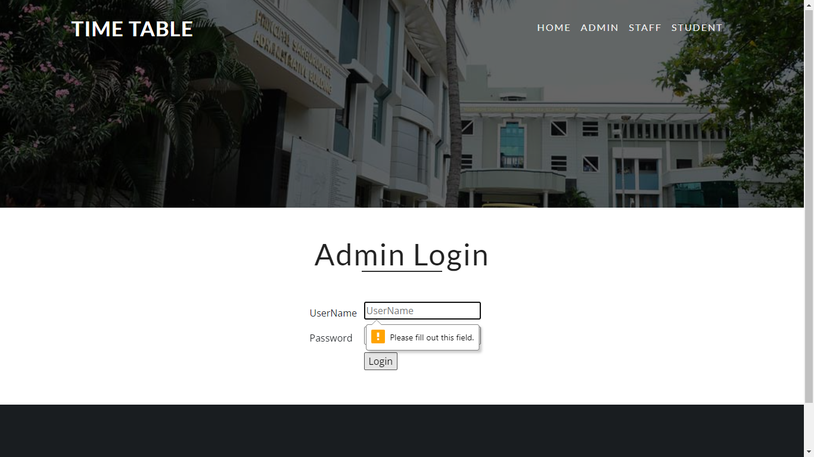

**Fig 3 Validation Testing**

**CHAPTER VI**

**6. CONCLUSION**

Separate timetable for the individual class, faculty and labs are generated automatically by this system. Various slot combinations can be acquired so that another timetable is generated as of need. The project reduces time consumption and he pain in framing the timetable manually. The project is developed in such a way that, no slot clashes occur providing features to tailor the timetable as of wish. Additional features that are included in the project is that faculty replacement is also made possible by listing out the available faculty who are eligible to be assigned as temporary faculty until a replacement faculty is assigned The future enhancement that can be developed from the project is to generate the master timetable for the departments and to the entire college. This enhancement can be achieved my making further modifications keeping the approach and techniques used for this project. It is complicated task that to handle many Faculty’s and allocating subjects for them at a time physically. So our proposed system will help to overcome this disadvantage. Thus we can produce timetable for any number of courses and multiple semesters. This system will help to create dynamic pages so that for implementing such a system we can make use of the different tools are widely applicable and free to use also in any institutions.

**CHAPTER VII**

**7. REFERENCES**

**BOOK REFERENCES**

1. Head First PHP & MySQL – by Lynn Begley & Michael Morrison
2. Learning PHP, Myself, JavaScript, and CSS: A Step-by-Step Guide to Creating Dynamic Websites – by Robin Nixon
3. PHP & Myself Web Development – by Luke Welling & Laura Thompson
4. PHP & Myself: The Missing Manual – by Brett McLaughlin
5. PHP: A Beginner’s Guide – by Vicar Aswan

**WEB REFERENCES**

1. https://www.w3schools.com/php/php_intro.asp
2. https://en.wikipedia.org/wiki/PHP
3. <https://www.tutorialspoint.com/php/php_introduction.htm>
4. https://www.php.net/manual/en/intro-whatis.php

**CHAPTER VIII**

**8. APPENDIX**

**8.1. Source Code**

Admin

<?php

extract($_POST);

session_start();

include("dbconnect.php");

if(isset($_POST['btn']))

{

$uname=$_REQUEST['username'];

$password=$_REQUEST['password'];

if($conn->connect_error)

{

die("Connection failed: " . $conn->connect_error);

}

else

{

$qry="select * from admin where username='$uname' and password='$password'";

$result = mysqli_query($conn, $qry);

if (mysqli_num_rows($result))

{

?>

<script language="javascript">

alert("login Success");

window.location.href="admin_home.php";

</script>

<?php

}

else

{

?>

<script language="javascript">

alert("Invalid user");

</script>

<?php

}

}

$conn->close();

}

?>

<!--

author: W3layouts

author URL: http://w3layouts.com

License: Creative Commons Attribution 3.0 Unported

License URL: http://creativecommons.org/licenses/by/3.0/

-->

<!DOCTYPE html>

<html lang="en">

<head>

<title>Time Table Generation | Admin </title>

<!-- for-mobile-apps -->

<meta name="viewport" content="width=device-width, initial-scale=1">

<meta http-equiv="Content-Type" content="text/html; charset=utf-8" />

<meta name="keywords" content="Fitness Health Responsive web template, Bootstrap Web Templates, Flat Web Templates, Android Compatible web template,

Smartphone Compatible web template, free webdesigns for Nokia, Samsung, LG, SonyEricsson, Motorola web design" />

<script>

addEventListener("load", function () {

setTimeout(hideURLbar, 0);

}, false);

function hideURLbar() {

window.scrollTo(0, 1);

}

</script>

<!-- css files -->

<link href="css/bootstrap.css" rel='stylesheet' type='text/css' /><!-- bootstrap css -->

<link href="css/style.css" rel='stylesheet' type='text/css' /><!-- custom css -->

<link href="css/fontawesome-all.css" rel="stylesheet"><!-- fontawesome css -->

<!-- //css files -->

<!-- google fonts -->

<link href="//fonts.googleapis.com/css?family=Lato:100,100i,300,300i,400,400i,700,700i,900,900i&amp;subset=latin-ext" rel="stylesheet">

<link href="//fonts.googleapis.com/css?family=Open+Sans:300,300i,400,400i,600,600i,700,700i,800,800i&amp;subset=cyrillic,cyrillic-ext,greek,greek-ext,latin-ext,vietnamese" rel="stylesheet">

<!-- //google fonts -->

<!-- scrolling script -->

<script>

jQuery(document).ready(function($) {

$(".scroll").click(function(event){

event.preventDefault();

$('html,body').animate({scrollTop:$(this.hash).offset().top},1000);

});

});

</script>

<!-- //scrolling script -->

</head>

<body>

<!-- header -->

<header>

<nav class="navbar navbar-expand-lg navbar-light">

<div class="container">

<h1>

<a class="navbar-brand text-white" href="#">

TIME TABLE

</a>

</h1>

<button class="navbar-toggler" type="button" data-toggle="collapse" data-target="#navbarSupportedContent" aria-controls="navbarSupportedContent"

aria-expanded="false" aria-label="Toggle navigation">

<span class="navbar-toggler-icon"></span>

</button>

<div class="collapse navbar-collapse" id="navbarSupportedContent">

<ul class="navbar-nav ml-lg-auto text-center align-items-center">

<li class="nav-item mr-lg-3 mt-lg-0 mt-3">

<a class="nav-link" href="index.php">Home

<span class="sr-only">(current)</span>

</a>

</li>

<li class="nav-item mr-lg-3 mt-lg-0 mt-3">

<a class="nav-link" href="admin.php">Admin </a>

</li>

<li class="nav-item mr-lg-3 mt-lg-0 mt-3">

<a class="nav-link" href="staff.php">Staff </a>

</li>

<li class="nav-item mr-lg-3 mt-lg-0 mt-3">

<a class="nav-link" href="student.php">Student </a>

</li>

</ul>

</div>

</div>

<!-- /.container -->

</nav>

</header>

<!-- //header -->

<!-- banner -->

<div class="innerpage-banner">

<div class="inner-page-layer">

</div>

</div>

<!-- //banner -->

<!-- about -->

<!-- //about -->

<!-- about bottom -->

<!-- //about bottom -->

<!-- Trainers -->

<section class="trainers py-5">

<h3 class="heading text-center mb-5">Admin Login </h3>

<form name="form1" method="post" action="">

<table width="312" height="127" border="0" align="center">

<tr>

<td>UserName</td>

<td><label>

<input name="username" type="text" id="username" required="" placeholder="UserName">

</label></td>

</tr>

<tr>

<td>Password</td>

<td><label>

<input name="password" type="password" id="password" required="" placeholder="Password">

</label></td>

</tr>

<tr>

<td>&nbsp;</td>

<td><label>

<input name="btn" type="submit" id="btn" value="Login">

</label></td>

</tr>

</table>

</form>

</section>

<!-- //Trainers -->

<!-- create -->

<!-- //create -->

<!-- social icons -->

<!-- //social icons -->

<!-- footer -->

<footer class="py-5">

<div class="copyright mt-5 text-center">

<p>All Rights Reserved | Design by <a href="#"> Admin</a> </p>

</div>

</footer>

<!-- //footer -->

<!--model-forms-->

<!--/Login-->

<div class="modal fade" id="exampleModalCenter" tabindex="-1" role="dialog" aria-hidden="true">

<div class="modal-dialog modal-dialog-centered" role="document">

<div class="modal-content">

<div class="modal-header text-center">

<button type="button" class="close" data-dismiss="modal" aria-label="Close">

<span aria-hidden="true">&times;</span>

</button>

</div>

<div class="modal-body">

<div class="login px-4 mx-auto mw-100">

<h5 class="text-center mb-4">Login Now</h5>

<form action="#" method="post">

<div class="form-group">

<label class="mb-2">Email address</label>

<input type="email" class="form-control" id="exampleInputEmail1" aria-describedby="emailHelp" placeholder="" required="">

<small id="emailHelp" class="form-text text-muted">We'll never share your email with anyone else.</small>

</div>

<div class="form-group">

<label class="mb-2">Password</label>

<input type="password" class="form-control" id="exampleInputPassword1" placeholder="" required="">

</div>

<div class="form-check mb-2">

<input type="checkbox" class="form-check-input" id="exampleCheck1">

<label class="form-check-label" for="exampleCheck1">Check me out</label>

</div>

<button type="submit" class="btn btn-primary submit mb-4">Sign In</button>

<p class="text-center pb-4">

<a href="#" data-toggle="modal" data-target="#exampleModalCenter2"> Don't have an account?</a>

</p>

</form>

</div>

</div>

</div>

</div>

</div>

<!--//Login-->

<!--/Register-->

<div class="modal fade" id="exampleModalCenter2" tabindex="-1" role="dialog" aria-hidden="true">

<div class="modal-dialog modal-dialog-centered" role="document">

<div class="modal-content">

<div class="modal-header text-center">

<button type="button" class="close" data-dismiss="modal" aria-label="Close">

<span aria-hidden="true">&times;</span>

</button>

</div>

<div class="modal-body">

<div class="login px-4 mx-auto mw-100">

<h5 class="text-center mb-4">Register Now</h5>

<form action="#" method="post">

<div class="form-group">

<label>First name</label>

<input type="text" class="form-control" id="validationDefault01" placeholder="" required="">

</div>

<div class="form-group">

<label>Last name</label>

<input type="text" class="form-control" id="validationDefault02" placeholder="" required="">

</div>

<div class="form-group">

<label class="mb-2">Password</label>

<input type="password" class="form-control" id="password1" placeholder="" required="">

</div>

<div class="form-group">

<label>Confirm Password</label>

<input type="password" class="form-control" id="password2" placeholder="" required="">

</div>

<button type="submit" class="btn btn-primary submit mb-4">Register</button>

<p class="text-center pb-4">

<a href="#">By clicking Register, I agree to your terms</a>

</p>

</form>

</div>

</div>

</div>

</div>

</div>

<!--//Register-->

<!--//model-forms-->

<!-- js -->

<script src="js/jquery-2.2.3.min.js"></script>

<script src="js/bootstrap.js"></script>

<!-- //js -->

<!-- Banner text Responsiveslides -->

<script src="js/responsiveslides.min.js"></script>

<script>

// You can also use"$(window).load(function() {"

$(function () {

// Slideshow 4

$("#slider3").responsiveSlides({

auto: true,

pager: true,

nav: false,

speed: 500,

namespace: "callbacks",

before: function () {

$('.events').append("<li>before event fired.</li>");

},

after: function () {

$('.events').append("<li>after event fired.</li>");

}

});

});

</script>

<!-- //Banner text Responsiveslides -->

<script src="js/smoothscroll.js"></script><!-- Smooth scrolling -->

<!-- start-smoth-scrolling -->

<script src="js/move-top.js"></script>

<script src="js/easing.js"></script>

<script>

jQuery(document).ready(function ($) {

$(".scroll").click(function (event) {

event.preventDefault();

$('html,body').animate({

scrollTop: $(this.hash).offset().top

}, 900);

});

});

</script>

<script>

$(document).ready(function () {

/*

var defaults = {

containerID: 'toTop', // fading element id

containerHoverID: 'toTopHover', // fading element hover id

scrollSpeed: 1200,

easingType: 'linear'

};

*/

$().UItoTop({

easingType: 'easeOutQuart'

});

});

</script>

<!-- //end-smoth-scrolling -->

</body>

</html>

**Admin Add Staff**

<?php

extract($_POST);

session_start();

include("dbconnect.php");

if(isset($btn))

{

$sname=$_REQUEST['name'];

$email=$_REQUEST['contact'];

$qualification=$_REQUEST['address'];

$experience=$_REQUEST['mail'];

$depart=$_REQUEST['department'];

$uname=$_REQUEST['username'];

$pass=$_REQUEST['password'];

$sql = "SELECT id FROM add_staff ";

$sid=0;

$result = $conn->query($sql);

while($row = $result->fetch_assoc())

{

$sid=$row['id'];

}

$sid=$sid+1;

$qq="insert into add_staff values('$sid','$sname','$email','$qualification','$experience','$depart','$uname','$pass','0','0')";

if ($conn->query($qq) === TRUE){

?>

<script language="javascript" type="text/javascript">

alert("Add SuccessFully");

window.location.href="admin_home.php";

</script>

<?php

}

else

{

?>

<script language="javascript" type="text/javascript">

alert("Failed");

</script>

<?php

}

$conn->close();

}

?>

<!--

author: W3layouts

author URL: http://w3layouts.com

License: Creative Commons Attribution 3.0 Unported

License URL: http://creativecommons.org/licenses/by/3.0/

-->

<!DOCTYPE html>

<html lang="en">

<head>

<title>Time Table Generation | Admin </title>

<!-- for-mobile-apps -->

<meta name="viewport" content="width=device-width, initial-scale=1">

<meta http-equiv="Content-Type" content="text/html; charset=utf-8" />

<meta name="keywords" content="Fitness Health Responsive web template, Bootstrap Web Templates, Flat Web Templates, Android Compatible web template,

Smartphone Compatible web template, free webdesigns for Nokia, Samsung, LG, SonyEricsson, Motorola web design" />

<script>

addEventListener("load", function () {

setTimeout(hideURLbar, 0);

}, false);

function hideURLbar() {

window.scrollTo(0, 1);

}

</script>

<!-- css files -->

<link href="css/bootstrap.css" rel='stylesheet' type='text/css' /><!-- bootstrap css -->

<link href="css/style.css" rel='stylesheet' type='text/css' /><!-- custom css -->

<link href="css/fontawesome-all.css" rel="stylesheet"><!-- fontawesome css -->

<!-- //css files -->

<!-- google fonts -->

<link href="//fonts.googleapis.com/css?family=Lato:100,100i,300,300i,400,400i,700,700i,900,900i&amp;subset=latin-ext" rel="stylesheet">

<link href="//fonts.googleapis.com/css?family=Open+Sans:300,300i,400,400i,600,600i,700,700i,800,800i&amp;subset=cyrillic,cyrillic-ext,greek,greek-ext,latin-ext,vietnamese" rel="stylesheet">

<!-- //google fonts -->

<!-- scrolling script -->

<script>

jQuery(document).ready(function($) {

$(".scroll").click(function(event){

event.preventDefault();

$('html,body').animate({scrollTop:$(this.hash).offset().top},1000);

});

});

</script>

<!-- //scrolling script -->

</head>

<body>

<!-- header -->

<header>

<nav class="navbar navbar-expand-lg navbar-light">

<div class="container">

<h1>

<a class="navbar-brand text-white" href="#">

TIME TABLE

</a>

</h1>

<button class="navbar-toggler" type="button" data-toggle="collapse" data-target="#navbarSupportedContent" aria-controls="navbarSupportedContent"

aria-expanded="false" aria-label="Toggle navigation">

<span class="navbar-toggler-icon"></span>

</button>

<div class="collapse navbar-collapse" id="navbarSupportedContent">

<ul class="navbar-nav ml-lg-auto text-center align-items-center">

<li class="nav-item mr-lg-3 mt-lg-0 mt-3">

<a class="nav-link" href="admin_home.php">Home

<span class="sr-only">(current)</span>

</a>

</li>

<li class="nav-item mr-lg-3 mt-lg-0 mt-3">

<a class="nav-link" href="admin_add_staff.php">Add Staff </a>

</li>

<li class="nav-item mr-lg-3 mt-lg-0 mt-3">

<a class="nav-link" href="admin_allot_timetable.php">Allot TimeTable </a>

</li>

<li class="nav-item mr-lg-3 mt-lg-0 mt-3">

<a class="nav-link" href="admin_timetable_department.php">TimeTable Department </a>

</li>

<li class="nav-item mr-lg-3 mt-lg-0 mt-3">

<a class="nav-link" href="index.php">Logout </a>

</li>

</ul>

</div>

</div>

<!-- /.container -->

</nav>

</header>

<!-- //header -->

<!-- banner -->

<div class="innerpage-banner">

<div class="inner-page-layer">

</div>

</div>

<!-- //banner -->

<!-- about -->

<!-- //about -->

<!-- about bottom -->

<!-- //about bottom -->

<!-- Trainers -->

<section class="trainers py-5">

<h3 class="heading text-center mb-5">Add Staff </h3>

<form name="form1" method="post" action="">

<table width="363" height="246" border="0" align="center">

<tr>

<td>Staff Name </td>

<td><input name="name" type="text" id="name" placeholder="Staff Name" required=""></td>

</tr>

<tr>

<td>Contact</td>

<td><label>

<input name="contact" type="text" id="contact" placeholder="Contact" required="">

</label></td>

</tr>

<tr>

<td>Address</td>

<td><label>

<input name="address" type="text" id="address" placeholder="Address" required="">

</label></td>

</tr>

<tr>

<td>EMail_ID</td>

<td><label>

<input name="mail" type="text" id="mail" placeholder="Email_ID" required="">

</label></td>

</tr>

<tr>

<td>Department</td>

<td><label>

<select name="department" id="department">

<option value="B.Sc(C.S)" selected>B.Sc(C.S)</option>

<option value="BCA">BCA</option>

<option value="MCA">MCA</option>

<option value="M.Sc(C.S)">M.Sc(C.S)</option>

<option value="M.Sc(IT)">M.Sc(IT)</option>

</select>

</label></td>

</tr>

<tr>

<td>UserName</td>

<td><label>

<input name="username" type="text" id="username" placeholder="UserName" required="">

</label></td>

</tr>

<tr>

<td>Password</td>

<td><label>

<input name="password" type="password" id="password" value="" placeholder="Password" required="">

</label></td>

</tr>

<tr>

<td>&nbsp;</td>

<td><label>

<input name="btn" type="submit" id="btn" value="Add">

</label></td>

</tr>

</table>

</form>

</section>

<!-- //Trainers -->

<!-- create -->

<!-- //create -->

<!-- social icons -->

<!-- //social icons -->

<!-- footer -->

<footer class="py-5">

<div class="copyright mt-5 text-center">

<p>All Rights Reserved | Design by <a href="#"> Admin</a> </p>

</div>

</footer>

<!-- //footer -->

<!--model-forms-->

<!--/Login-->

<div class="modal fade" id="exampleModalCenter" tabindex="-1" role="dialog" aria-hidden="true">

<div class="modal-dialog modal-dialog-centered" role="document">

<div class="modal-content">

<div class="modal-header text-center">

<button type="button" class="close" data-dismiss="modal" aria-label="Close">

<span aria-hidden="true">&times;</span>

</button>

</div>

<div class="modal-body">

<div class="login px-4 mx-auto mw-100">

<h5 class="text-center mb-4">Login Now</h5>

<form action="#" method="post">

<div class="form-group">

<label class="mb-2">Email address</label>

<input type="email" class="form-control" id="exampleInputEmail1" aria-describedby="emailHelp" placeholder="" required="">

<small id="emailHelp" class="form-text text-muted">We'll never share your email with anyone else.</small>

</div>

<div class="form-group">

<label class="mb-2">Password</label>

<input type="password" class="form-control" id="exampleInputPassword1" placeholder="" required="">

</div>

<div class="form-check mb-2">

<input type="checkbox" class="form-check-input" id="exampleCheck1">

<label class="form-check-label" for="exampleCheck1">Check me out</label>

</div>

<button type="submit" class="btn btn-primary submit mb-4">Sign In</button>

<p class="text-center pb-4">

<a href="#" data-toggle="modal" data-target="#exampleModalCenter2"> Don't have an account?</a>

</p>

</form>

</div>

</div>

</div>

</div>

</div>

<!--//Login-->

<!--/Register-->

<div class="modal fade" id="exampleModalCenter2" tabindex="-1" role="dialog" aria-hidden="true">

<div class="modal-dialog modal-dialog-centered" role="document">

<div class="modal-content">

<div class="modal-header text-center">

<button type="button" class="close" data-dismiss="modal" aria-label="Close">

<span aria-hidden="true">&times;</span>

</button>

</div>

<div class="modal-body">

<div class="login px-4 mx-auto mw-100">

<h5 class="text-center mb-4">Register Now</h5>

<form action="#" method="post">

<div class="form-group">

<label>First name</label>

<input type="text" class="form-control" id="validationDefault01" placeholder="" required="">

</div>

<div class="form-group">

<label>Last name</label>

<input type="text" class="form-control" id="validationDefault02" placeholder="" required="">

</div>

<div class="form-group">

<label class="mb-2">Password</label>

<input type="password" class="form-control" id="password1" placeholder="" required="">

</div>

<div class="form-group">

<label>Confirm Password</label>

<input type="password" class="form-control" id="password2" placeholder="" required="">

</div>

<button type="submit" class="btn btn-primary submit mb-4">Register</button>

<p class="text-center pb-4">

<a href="#">By clicking Register, I agree to your terms</a>

</p>

</form>

</div>

</div>

</div>

</div>

</div>

<!--//Register-->

<!--//model-forms-->

<!-- js -->

<script src="js/jquery-2.2.3.min.js"></script>

<script src="js/bootstrap.js"></script>

<!-- //js -->

<!-- Banner text Responsiveslides -->

<script src="js/responsiveslides.min.js"></script>

<script>

// You can also use"$(window).load(function() {"

$(function () {

// Slideshow 4

$("#slider3").responsiveSlides({

auto: true,

pager: true,

nav: false,

speed: 500,

namespace: "callbacks",

before: function () {

$('.events').append("<li>before event fired.</li>");

},

after: function () {

$('.events').append("<li>after event fired.</li>");

}

});

});

</script>

<!-- //Banner text Responsiveslides -->

<script src="js/smoothscroll.js"></script><!-- Smooth scrolling -->

<!-- start-smoth-scrolling -->

<script src="js/move-top.js"></script>

<script src="js/easing.js"></script>

<script>

jQuery(document).ready(function ($) {

$(".scroll").click(function (event) {

event.preventDefault();

$('html,body').animate({

scrollTop: $(this.hash).offset().top

}, 900);

});

});

</script>

<script>

$(document).ready(function () {

/*

var defaults = {

containerID: 'toTop', // fading element id

containerHoverID: 'toTopHover', // fading element hover id

scrollSpeed: 1200,

easingType: 'linear'

};

*/

$().UItoTop({

easingType: 'easeOutQuart'

});

});

</script>

<!-- //end-smoth-scrolling -->

</body>

</html>

Admin Allot Time Table

<?php

extract($_POST);

session_start();

include("dbconnect.php");

?>

<!--

author: W3layouts

author URL: http://w3layouts.com

License: Creative Commons Attribution 3.0 Unported

License URL: http://creativecommons.org/licenses/by/3.0/

-->

<!DOCTYPE html>

<html lang="en">

<head>

<title>Time Table Generation | Admin </title>

<!-- for-mobile-apps -->

<meta name="viewport" content="width=device-width, initial-scale=1">

<meta http-equiv="Content-Type" content="text/html; charset=utf-8" />

<meta name="keywords" content="Fitness Health Responsive web template, Bootstrap Web Templates, Flat Web Templates, Android Compatible web template,

Smartphone Compatible web template, free webdesigns for Nokia, Samsung, LG, SonyEricsson, Motorola web design" />

<script>

addEventListener("load", function () {

setTimeout(hideURLbar, 0);

}, false);

function hideURLbar() {

window.scrollTo(0, 1);

}

</script>

<!-- css files -->

<link href="css/bootstrap.css" rel='stylesheet' type='text/css' /><!-- bootstrap css -->

<link href="css/style.css" rel='stylesheet' type='text/css' /><!-- custom css -->

<link href="css/fontawesome-all.css" rel="stylesheet"><!-- fontawesome css -->

<!-- //css files -->

<!-- google fonts -->

<link href="//fonts.googleapis.com/css?family=Lato:100,100i,300,300i,400,400i,700,700i,900,900i&amp;subset=latin-ext" rel="stylesheet">

<link href="//fonts.googleapis.com/css?family=Open+Sans:300,300i,400,400i,600,600i,700,700i,800,800i&amp;subset=cyrillic,cyrillic-ext,greek,greek-ext,latin-ext,vietnamese" rel="stylesheet">

<!-- //google fonts -->

<!-- scrolling script -->

<script>

jQuery(document).ready(function($) {

$(".scroll").click(function(event){

event.preventDefault();

$('html,body').animate({scrollTop:$(this.hash).offset().top},1000);

});

});

</script>

<!-- //scrolling script -->

</head>

<body>

<!-- header -->

<header>

<nav class="navbar navbar-expand-lg navbar-light">

<div class="container">

<h1>

<a class="navbar-brand text-white" href="#">

TIME TABLE

</a>

</h1>

<button class="navbar-toggler" type="button" data-toggle="collapse" data-target="#navbarSupportedContent" aria-controls="navbarSupportedContent"

aria-expanded="false" aria-label="Toggle navigation">

<span class="navbar-toggler-icon"></span>

</button>

<div class="collapse navbar-collapse" id="navbarSupportedContent">

<ul class="navbar-nav ml-lg-auto text-center align-items-center">

<li class="nav-item mr-lg-3 mt-lg-0 mt-3">

<a class="nav-link" href="admin_home.php">Home

<span class="sr-only">(current)</span>

</a>

</li>

<li class="nav-item mr-lg-3 mt-lg-0 mt-3">

<a class="nav-link" href="admin_add_staff.php">Add Staff </a>

</li>

<li class="nav-item mr-lg-3 mt-lg-0 mt-3">

<a class="nav-link" href="admin_allot_timetable_home.php">Allot TimeTable </a>

</li>

<li class="nav-item mr-lg-3 mt-lg-0 mt-3">

<a class="nav-link" href="admin_timetable_department.php">TimeTable Department </a>

</li>

<li class="nav-item mr-lg-3 mt-lg-0 mt-3">

<a class="nav-link" href="index.php">Logout </a>

</li>

</ul>

</div>

</div>

<!-- /.container -->

</nav>

</header>

<!-- //header -->

<!-- banner -->

<div class="innerpage-banner">

<div class="inner-page-layer">

</div>

</div>

<!-- //banner -->

<!-- about -->

<!-- //about -->

<!-- about bottom -->

<!-- //about bottom -->

<!-- Trainers -->

<section class="trainers py-5">

<h3 class="heading text-center mb-5">Allot TimeTable </h3>

<form name="form1" method="post" action=""> </form>

</section>

<!-- //Trainers -->

<!-- create -->

<!-- //create -->

<!-- social icons -->

<!-- //social icons -->

<!-- footer -->

<footer class="py-5">

<div class="copyright mt-5 text-center">

<p>All Rights Reserved | Design by <a href="#"> Admin</a> </p>

</div>

</footer>

<!-- //footer -->

<!--model-forms-->

<!--/Login-->

<div class="modal fade" id="exampleModalCenter" tabindex="-1" role="dialog" aria-hidden="true">

<div class="modal-dialog modal-dialog-centered" role="document">

<div class="modal-content">

<div class="modal-header text-center">

<button type="button" class="close" data-dismiss="modal" aria-label="Close">

<span aria-hidden="true">&times;</span>

</button>

</div>

<div class="modal-body">

<div class="login px-4 mx-auto mw-100">

<h5 class="text-center mb-4">Login Now</h5>

<form action="#" method="post">

<div class="form-group">

<label class="mb-2">Email address</label>

<input type="email" class="form-control" id="exampleInputEmail1" aria-describedby="emailHelp" placeholder="" required="">

<small id="emailHelp" class="form-text text-muted">We'll never share your email with anyone else.</small>

</div>

<div class="form-group">

<label class="mb-2">Password</label>

<input type="password" class="form-control" id="exampleInputPassword1" placeholder="" required="">

</div>

<div class="form-check mb-2">

<input type="checkbox" class="form-check-input" id="exampleCheck1">

<label class="form-check-label" for="exampleCheck1">Check me out</label>

</div>

<button type="submit" class="btn btn-primary submit mb-4">Sign In</button>

<p class="text-center pb-4">

<a href="#" data-toggle="modal" data-target="#exampleModalCenter2"> Don't have an account?</a>

</p>

</form>

</div>

</div>

</div>

</div>

</div>

<!--//Login-->

<!--/Register-->

<div class="modal fade" id="exampleModalCenter2" tabindex="-1" role="dialog" aria-hidden="true">

<div class="modal-dialog modal-dialog-centered" role="document">

<div class="modal-content">

<div class="modal-header text-center">

<button type="button" class="close" data-dismiss="modal" aria-label="Close">

<span aria-hidden="true">&times;</span>

</button>

</div>

<div class="modal-body">

<div class="login px-4 mx-auto mw-100">

<h5 class="text-center mb-4">Register Now</h5>

<form action="#" method="post">

<div class="form-group">

<label>First name</label>

<input type="text" class="form-control" id="validationDefault01" placeholder="" required="">

</div>

<div class="form-group">

<label>Last name</label>

<input type="text" class="form-control" id="validationDefault02" placeholder="" required="">

</div>

<div class="form-group">

<label class="mb-2">Password</label>

<input type="password" class="form-control" id="password1" placeholder="" required="">

</div>

<div class="form-group">

<label>Confirm Password</label>

<input type="password" class="form-control" id="password2" placeholder="" required="">

</div>

<button type="submit" class="btn btn-primary submit mb-4">Register</button>

<p class="text-center pb-4">

<a href="#">By clicking Register, I agree to your terms</a>

</p>

</form>

</div>

</div>

</div>

</div>

</div>

<!--//Register-->

<!--//model-forms-->

<!-- js -->

<script src="js/jquery-2.2.3.min.js"></script>

<script src="js/bootstrap.js"></script>

<!-- //js -->

<!-- Banner text Responsiveslides -->

<script src="js/responsiveslides.min.js"></script>

<script>

// You can also use"$(window).load(function() {"

$(function () {

// Slideshow 4

$("#slider3").responsiveSlides({

auto: true,

pager: true,

nav: false,

speed: 500,

namespace: "callbacks",

before: function () {

$('.events').append("<li>before event fired.</li>");

},

after: function () {

$('.events').append("<li>after event fired.</li>");

}

});

});

</script>

<!-- //Banner text Responsiveslides -->

<script src="js/smoothscroll.js"></script><!-- Smooth scrolling -->

<!-- start-smoth-scrolling -->

<script src="js/move-top.js"></script>

<script src="js/easing.js"></script>

<script>

jQuery(document).ready(function ($) {

$(".scroll").click(function (event) {

event.preventDefault();

$('html,body').animate({

scrollTop: $(this.hash).offset().top

}, 900);

});

});

</script>

<script>

$(document).ready(function () {

/*

var defaults = {

containerID: 'toTop', // fading element id

containerHoverID: 'toTopHover', // fading element hover id

scrollSpeed: 1200,

easingType: 'linear'

};

*/

$().UItoTop({

easingType: 'easeOutQuart'

});

});

</script>

<!-- //end-smoth-scrolling -->

</body>

</html>

Admin Time Table Department

<?php

extract($_POST);

session_start();

include("dbconnect.php");

?>

<!--

author: W3layouts

author URL: http://w3layouts.com

License: Creative Commons Attribution 3.0 Unported

License URL: http://creativecommons.org/licenses/by/3.0/

-->

<!DOCTYPE html>

<html lang="en">

<head>

<title>Time Table Generation | Admin </title>

<!-- for-mobile-apps -->

<meta name="viewport" content="width=device-width, initial-scale=1">

<meta http-equiv="Content-Type" content="text/html; charset=utf-8" />

<meta name="keywords" content="Fitness Health Responsive web template, Bootstrap Web Templates, Flat Web Templates, Android Compatible web template,

Smartphone Compatible web template, free webdesigns for Nokia, Samsung, LG, SonyEricsson, Motorola web design" />

<script>

addEventListener("load", function () {

setTimeout(hideURLbar, 0);

}, false);

function hideURLbar() {

window.scrollTo(0, 1);

}

</script>

<!-- css files -->

<link href="css/bootstrap.css" rel='stylesheet' type='text/css' /><!-- bootstrap css -->

<link href="css/style.css" rel='stylesheet' type='text/css' /><!-- custom css -->

<link href="css/fontawesome-all.css" rel="stylesheet"><!-- fontawesome css -->

<!-- //css files -->

<!-- google fonts -->

<link href="//fonts.googleapis.com/css?family=Lato:100,100i,300,300i,400,400i,700,700i,900,900i&amp;subset=latin-ext" rel="stylesheet">

<link href="//fonts.googleapis.com/css?family=Open+Sans:300,300i,400,400i,600,600i,700,700i,800,800i&amp;subset=cyrillic,cyrillic-ext,greek,greek-ext,latin-ext,vietnamese" rel="stylesheet">

<!-- //google fonts -->

<!-- scrolling script -->

<script>

jQuery(document).ready(function($) {

$(".scroll").click(function(event){

event.preventDefault();

$('html,body').animate({scrollTop:$(this.hash).offset().top},1000);

});

});

</script>

<!-- //scrolling script -->

</head>

<body>

<!-- header -->

<header>

<nav class="navbar navbar-expand-lg navbar-light">

<div class="container">

<h1>

<a class="navbar-brand text-white" href="#">

TIME TABLE

</a>

</h1>

<button class="navbar-toggler" type="button" data-toggle="collapse" data-target="#navbarSupportedContent" aria-controls="navbarSupportedContent"

aria-expanded="false" aria-label="Toggle navigation">

<span class="navbar-toggler-icon"></span>

</button>

<div class="collapse navbar-collapse" id="navbarSupportedContent">

<ul class="navbar-nav ml-lg-auto text-center align-items-center">

<li class="nav-item mr-lg-3 mt-lg-0 mt-3">

<a class="nav-link" href="admin_home.php">Home

<span class="sr-only">(current)</span>

</a>

</li>

<li class="nav-item mr-lg-3 mt-lg-0 mt-3">

<a class="nav-link" href="admin_add_staff.php">Add Staff </a>

</li>

<li class="nav-item mr-lg-3 mt-lg-0 mt-3">

<a class="nav-link" href="admin_allot_timetable.php">Allot TimeTable </a>

</li>

<li class="nav-item mr-lg-3 mt-lg-0 mt-3">

<a class="nav-link" href="admin_timetable_department.php">TimeTable Department </a>

</li>

<li class="nav-item mr-lg-3 mt-lg-0 mt-3">

<a class="nav-link" href="index.php">Logout </a>

</li>

</ul>

</div>

</div>

<!-- /.container -->

</nav>

</header>

<!-- //header -->

<!-- banner -->

<div class="innerpage-banner">

<div class="inner-page-layer">

</div>

</div>

<!-- //banner -->

<!-- about -->

<!-- //about -->

<!-- about bottom -->

<!-- //about bottom -->

<!-- Trainers -->

<section class="trainers py-5">

<h3 class="heading text-center mb-5">TimeTable Department </h3>

<form name="form1" method="post" action="">

<table width="521" height="91" border="0" align="center">

<tr>

<td>Day1:</td>

<td>&nbsp;</td>

<td>&nbsp;</td>

<td>&nbsp;</td>

<td>&nbsp;</td>

</tr>

<tr>

<td>Department</td>

<td>Staff</td>

<td>Subject</td>

<td>Time</td>

<td>Period</td>

</tr>

<?php

$qq="Select * from day1";

$result =$conn->query($qq);

while($row =$result->fetch_assoc())

{

?>

<tr>

<td><?php echo $row['department'];?></td>

<td><?php echo $row['staffname'];?></td>

<td><?php echo $row['subject'];?></td>

<td><?php echo $row['time'];?></td>

<td><?php echo $row['pd'];?></td>

<?php

}

?>

</table>

<p>&nbsp;</p>

<table width="521" height="91" border="0" align="center">

<tr>

<td>Day2:</td>

<td>&nbsp;</td>

<td>&nbsp;</td>

<td>&nbsp;</td>

<td>&nbsp;</td>

</tr>

<tr>

<td>Department</td>

<td>Staff</td>

<td>Subject</td>

<td>Time</td>

<td>Period</td>

</tr>

<?php

$qq="Select * from day2";

$result =$conn->query($qq);

while($row =$result->fetch_assoc())

{

?>

<tr>

<td><?php echo $row['department'];?></td>

<td><?php echo $row['staffname'];?></td>

<td><?php echo $row['subject'];?></td>

<td><?php echo $row['time'];?></td>

<td><?php echo $row['pd'];?></td>

<?php

}

?>

</table>

<p>&nbsp;</p>

<table width="521" height="91" border="0" align="center">

<tr>

<td>Day3:</td>

<td>&nbsp;</td>

<td>&nbsp;</td>

<td>&nbsp;</td>

<td>&nbsp;</td>

</tr>

<tr>

<td>Department</td>

<td>Staff</td>

<td>Subject</td>

<td>Time</td>

<td>Period</td>

</tr>

<?php

$qq="Select * from day3";

$result =$conn->query($qq);

while($row =$result->fetch_assoc())

{

?>

<tr>

<td><?php echo $row['department'];?></td>

<td><?php echo $row['staffname'];?></td>

<td><?php echo $row['subject'];?></td>

<td><?php echo $row['time'];?></td>

<td><?php echo $row['pd'];?></td>

<?php

}

?>

</table>

<p>&nbsp;</p>

<table width="521" height="91" border="0" align="center">

<tr>

<td>Day4:</td>

<td>&nbsp;</td>

<td>&nbsp;</td>

<td>&nbsp;</td>

<td>&nbsp;</td>

</tr>

<tr>

<td>Department</td>

<td>Staff</td>

<td>Subject</td>

<td>Time</td>

<td>Period</td>

</tr>

<?php

$qq="Select * from day4";

$result =$conn->query($qq);

while($row =$result->fetch_assoc())

{

?>

<tr>

<td><?php echo $row['department'];?></td>

<td><?php echo $row['staffname'];?></td>

<td><?php echo $row['subject'];?></td>

<td><?php echo $row['time'];?></td>

<td><?php echo $row['pd'];?></td>

<?php

}

?>

</table>

<p>&nbsp;</p>

<table width="521" height="91" border="0" align="center">

<tr>

<td>Day5:</td>

<td>&nbsp;</td>

<td>&nbsp;</td>

<td>&nbsp;</td>

<td>&nbsp;</td>

</tr>

<tr>

<td>Department</td>

<td>Staff</td>

<td>Subject</td>

<td>Time</td>

<td>Period</td>

</tr>

<?php

$qq="Select * from day5";

$result =$conn->query($qq);

while($row =$result->fetch_assoc())

{

?>

<tr>

<td><?php echo $row['department'];?></td>

<td><?php echo $row['staffname'];?></td>

<td><?php echo $row['subject'];?></td>

<td><?php echo $row['time'];?></td>

<td><?php echo $row['pd'];?></td>

<?php

}

?>

</table>

<p>&nbsp;</p>

<table width="521" height="91" border="0" align="center">

<tr>

<td>Day6:</td>

<td>&nbsp;</td>

<td>&nbsp;</td>

<td>&nbsp;</td>

<td>&nbsp;</td>

</tr>

<tr>

<td>Department</td>

<td>Staff</td>

<td>Subject</td>

<td>Time</td>

<td>Period</td>

</tr>

<?php

$qq="Select * from day6";

$result =$conn->query($qq);

while($row =$result->fetch_assoc())

{

?>

<tr>

<td><?php echo $row['department'];?></td>

<td><?php echo $row['staffname'];?></td>

<td><?php echo $row['subject'];?></td>

<td><?php echo $row['time'];?></td>

<td><?php echo $row['pd'];?></td>

<?php

}

?>

</table>

</form>

</section>

<!-- //Trainers -->

<!-- create -->

<!-- //create -->

<!-- social icons -->

<!-- //social icons -->

<!-- footer -->

<footer class="py-5">

<div class="copyright mt-5 text-center">

<p>All Rights Reserved | Design by <a href="#"> Admin</a> </p>

</div>

</footer>

<!-- //footer -->

<!--model-forms-->

<!--/Login-->

<div class="modal fade" id="exampleModalCenter" tabindex="-1" role="dialog" aria-hidden="true">

<div class="modal-dialog modal-dialog-centered" role="document">

<div class="modal-content">

<div class="modal-header text-center">

<button type="button" class="close" data-dismiss="modal" aria-label="Close">

<span aria-hidden="true">&times;</span>

</button>

</div>

<div class="modal-body">

<div class="login px-4 mx-auto mw-100">

<h5 class="text-center mb-4">Login Now</h5>

<form action="#" method="post">

<div class="form-group">

<label class="mb-2">Email address</label>

<input type="email" class="form-control" id="exampleInputEmail1" aria-describedby="emailHelp" placeholder="" required="">

<small id="emailHelp" class="form-text text-muted">We'll never share your email with anyone else.</small>

</div>

<div class="form-group">

<label class="mb-2">Password</label>

<input type="password" class="form-control" id="exampleInputPassword1" placeholder="" required="">

</div>

<div class="form-check mb-2">

<input type="checkbox" class="form-check-input" id="exampleCheck1">

<label class="form-check-label" for="exampleCheck1">Check me out</label>

</div>

<button type="submit" class="btn btn-primary submit mb-4">Sign In</button>

<p class="text-center pb-4">

<a href="#" data-toggle="modal" data-target="#exampleModalCenter2"> Don't have an account?</a>

</p>

</form>

</div>

</div>

</div>

</div>

</div>

<!--//Login-->

<!--/Register-->

<div class="modal fade" id="exampleModalCenter2" tabindex="-1" role="dialog" aria-hidden="true">

<div class="modal-dialog modal-dialog-centered" role="document">

<div class="modal-content">

<div class="modal-header text-center">

<button type="button" class="close" data-dismiss="modal" aria-label="Close">

<span aria-hidden="true">&times;</span>

</button>

</div>

<div class="modal-body">

<div class="login px-4 mx-auto mw-100">

<h5 class="text-center mb-4">Register Now</h5>

<form action="#" method="post">

<div class="form-group">

<label>First name</label>

<input type="text" class="form-control" id="validationDefault01" placeholder="" required="">

</div>

<div class="form-group">

<label>Last name</label>

<input type="text" class="form-control" id="validationDefault02" placeholder="" required="">

</div>

<div class="form-group">

<label class="mb-2">Password</label>

<input type="password" class="form-control" id="password1" placeholder="" required="">

</div>

<div class="form-group">

<label>Confirm Password</label>

<input type="password" class="form-control" id="password2" placeholder="" required="">

</div>

<button type="submit" class="btn btn-primary submit mb-4">Register</button>

<p class="text-center pb-4">

<a href="#">By clicking Register, I agree to your terms</a>

</p>

</form>

</div>

</div>

</div>

</div>

</div>

<!--//Register-->

<!--//model-forms-->

<!-- js -->

<script src="js/jquery-2.2.3.min.js"></script>

<script src="js/bootstrap.js"></script>

<!-- //js -->

<!-- Banner text Responsiveslides -->

<script src="js/responsiveslides.min.js"></script>

<script>

// You can also use"$(window).load(function() {"

$(function () {

// Slideshow 4

$("#slider3").responsiveSlides({

auto: true,

pager: true,

nav: false,

speed: 500,

namespace: "callbacks",

before: function () {

$('.events').append("<li>before event fired.</li>");

},

after: function () {

$('.events').append("<li>after event fired.</li>");

}

});

});

</script>

<!-- //Banner text Responsiveslides -->

<script src="js/smoothscroll.js"></script><!-- Smooth scrolling -->

<!-- start-smoth-scrolling -->

<script src="js/move-top.js"></script>

<script src="js/easing.js"></script>

<script>

jQuery(document).ready(function ($) {

$(".scroll").click(function (event) {

event.preventDefault();

$('html,body').animate({

scrollTop: $(this.hash).offset().top

}, 900);

});

});

</script>

<script>

$(document).ready(function () {

/*

var defaults = {

containerID: 'toTop', // fading element id

containerHoverID: 'toTopHover', // fading element hover id

scrollSpeed: 1200,

easingType: 'linear'

};

*/

$().UItoTop({

easingType: 'easeOutQuart'

});

});

</script>

<!-- //end-smoth-scrolling -->

</body>

</html>

Student

<?php

extract($_POST);

session_start();

include("dbconnect.php");

if(isset($_POST['btn']))

{

$uname=$_REQUEST['username'];

$password=$_REQUEST['password'];

if($conn->connect_error)

{

die("Connection failed: " . $conn->connect_error);

}

else

{

$qry="select * from user_register where username='$uname' and password='$password'";

$result = mysqli_query($conn, $qry);

if (mysqli_num_rows($result))

{

$_SESSION['uname']=$uname;

?>

<script language="javascript">

alert("login Success");

window.location.href="student_home.php";

</script>

<?php

}

else

{

?>

<script language="javascript">

alert("Invalid user");

</script>

<?php

}

}

$conn->close();

}

?>

<!--

author: W3layouts

author URL: http://w3layouts.com

License: Creative Commons Attribution 3.0 Unported

License URL: http://creativecommons.org/licenses/by/3.0/

-->

<!DOCTYPE html>

<html lang="en">

<head>

<title>Time Table Generation | Admin </title>

<!-- for-mobile-apps -->

<meta name="viewport" content="width=device-width, initial-scale=1">

<meta http-equiv="Content-Type" content="text/html; charset=utf-8" />

<meta name="keywords" content="Fitness Health Responsive web template, Bootstrap Web Templates, Flat Web Templates, Android Compatible web template,

Smartphone Compatible web template, free webdesigns for Nokia, Samsung, LG, SonyEricsson, Motorola web design" />

<script>

addEventListener("load", function () {

setTimeout(hideURLbar, 0);

}, false);

function hideURLbar() {

window.scrollTo(0, 1);

}

</script>

<!-- css files -->

<link href="css/bootstrap.css" rel='stylesheet' type='text/css' /><!-- bootstrap css -->

<link href="css/style.css" rel='stylesheet' type='text/css' /><!-- custom css -->

<link href="css/fontawesome-all.css" rel="stylesheet"><!-- fontawesome css -->

<!-- //css files -->

<!-- google fonts -->

<link href="//fonts.googleapis.com/css?family=Lato:100,100i,300,300i,400,400i,700,700i,900,900i&amp;subset=latin-ext" rel="stylesheet">

<link href="//fonts.googleapis.com/css?family=Open+Sans:300,300i,400,400i,600,600i,700,700i,800,800i&amp;subset=cyrillic,cyrillic-ext,greek,greek-ext,latin-ext,vietnamese" rel="stylesheet">

<!-- //google fonts -->

<!-- scrolling script -->

<script>

jQuery(document).ready(function($) {

$(".scroll").click(function(event){

event.preventDefault();

$('html,body').animate({scrollTop:$(this.hash).offset().top},1000);

});

});

</script>

<!-- //scrolling script -->

</head>

<body>

<!-- header -->

<header>

<nav class="navbar navbar-expand-lg navbar-light">

<div class="container">

<h1>

<a class="navbar-brand text-white" href="#">

TIME TABLE

</a>

</h1>

<button class="navbar-toggler" type="button" data-toggle="collapse" data-target="#navbarSupportedContent" aria-controls="navbarSupportedContent"

aria-expanded="false" aria-label="Toggle navigation">

<span class="navbar-toggler-icon"></span>

</button>

<div class="collapse navbar-collapse" id="navbarSupportedContent">

<ul class="navbar-nav ml-lg-auto text-center align-items-center">

<li class="nav-item mr-lg-3 mt-lg-0 mt-3">

<a class="nav-link" href="index.php">Home

<span class="sr-only">(current)</span>

</a>

</li>

<li class="nav-item mr-lg-3 mt-lg-0 mt-3">

<a class="nav-link" href="admin.php">Admin </a>

</li>

<li class="nav-item mr-lg-3 mt-lg-0 mt-3">

<a class="nav-link" href="staff.php">Staff </a>

</li>

<li class="nav-item mr-lg-3 mt-lg-0 mt-3">

<a class="nav-link" href="student.php">Student </a>

</li>

</ul>

</div>

</div>

<!-- /.container -->

</nav>

</header>

<!-- //header -->

<!-- banner -->

<div class="innerpage-banner">

<div class="inner-page-layer">

</div>

</div>

<!-- //banner -->

<!-- about -->

<!-- //about -->

<!-- about bottom -->

<!-- //about bottom -->

<!-- Trainers -->

<section class="trainers py-5">

<h3 class="heading text-center mb-5">Student Login </h3>

<form name="form1" method="post" action="">

<table width="312" height="127" border="0" align="center">

<tr>

<td>UserName</td>

<td><label>

<input name="username" type="text" id="username" required="" placeholder="UserName">

</label></td>

</tr>

<tr>

<td>Password</td>

<td><label>

<input name="password" type="password" id="password" required="" placeholder="Password">

</label></td>

</tr>

<tr>

<td>&nbsp;</td>

<td><label>

<input name="btn" type="submit" id="btn" value="Login">

</label></td>

</tr>

<tr>

<td>&nbsp;</td>

<td><a href="user_register.php">New Student ?</a> </td>

</tr>

</table>

</form>

</section>

<!-- //Trainers -->

<!-- create -->

<!-- //create -->

<!-- social icons -->

<!-- //social icons -->

<!-- footer -->

<footer class="py-5">

<div class="copyright mt-5 text-center">

<p>All Rights Reserved | Design by <a href="#"> Admin</a> </p>

</div>

</footer>

<!-- //footer -->

<!--model-forms-->

<!--/Login-->

<div class="modal fade" id="exampleModalCenter" tabindex="-1" role="dialog" aria-hidden="true">

<div class="modal-dialog modal-dialog-centered" role="document">

<div class="modal-content">

<div class="modal-header text-center">

<button type="button" class="close" data-dismiss="modal" aria-label="Close">

<span aria-hidden="true">&times;</span>

</button>

</div>

<div class="modal-body">

<div class="login px-4 mx-auto mw-100">

<h5 class="text-center mb-4">Login Now</h5>

<form action="#" method="post">

<div class="form-group">

<label class="mb-2">Email address</label>

<input type="email" class="form-control" id="exampleInputEmail1" aria-describedby="emailHelp" placeholder="" required="">

<small id="emailHelp" class="form-text text-muted">We'll never share your email with anyone else.</small>

</div>

<div class="form-group">

<label class="mb-2">Password</label>

<input type="password" class="form-control" id="exampleInputPassword1" placeholder="" required="">

</div>

<div class="form-check mb-2">

<input type="checkbox" class="form-check-input" id="exampleCheck1">

<label class="form-check-label" for="exampleCheck1">Check me out</label>

</div>

<button type="submit" class="btn btn-primary submit mb-4">Sign In</button>

<p class="text-center pb-4">

<a href="#" data-toggle="modal" data-target="#exampleModalCenter2"> Don't have an account?</a>

</p>

</form>

</div>

</div>

</div>

</div>

</div>

<!--//Login-->

<!--/Register-->

<div class="modal fade" id="exampleModalCenter2" tabindex="-1" role="dialog" aria-hidden="true">

<div class="modal-dialog modal-dialog-centered" role="document">

<div class="modal-content">

<div class="modal-header text-center">

<button type="button" class="close" data-dismiss="modal" aria-label="Close">

<span aria-hidden="true">&times;</span>

</button>

</div>

<div class="modal-body">

<div class="login px-4 mx-auto mw-100">

<h5 class="text-center mb-4">Register Now</h5>

<form action="#" method="post">

<div class="form-group">

<label>First name</label>

<input type="text" class="form-control" id="validationDefault01" placeholder="" required="">

</div>

<div class="form-group">

<label>Last name</label>

<input type="text" class="form-control" id="validationDefault02" placeholder="" required="">

</div>

<div class="form-group">

<label class="mb-2">Password</label>

<input type="password" class="form-control" id="password1" placeholder="" required="">

</div>

<div class="form-group">

<label>Confirm Password</label>

<input type="password" class="form-control" id="password2" placeholder="" required="">

</div>

<button type="submit" class="btn btn-primary submit mb-4">Register</button>

<p class="text-center pb-4">

<a href="#">By clicking Register, I agree to your terms</a>

</p>

</form>

</div>

</div>

</div>

</div>

</div>

<!--//Register-->

<!--//model-forms-->

<!-- js -->

<script src="js/jquery-2.2.3.min.js"></script>

<script src="js/bootstrap.js"></script>

<!-- //js -->

<!-- Banner text Responsiveslides -->

<script src="js/responsiveslides.min.js"></script>

<script>

// You can also use"$(window).load(function() {"

$(function () {

// Slideshow 4

$("#slider3").responsiveSlides({

auto: true,

pager: true,

nav: false,

speed: 500,

namespace: "callbacks",

before: function () {

$('.events').append("<li>before event fired.</li>");

},

after: function () {

$('.events').append("<li>after event fired.</li>");

}

});

});

</script>

<!-- //Banner text Responsiveslides -->

<script src="js/smoothscroll.js"></script><!-- Smooth scrolling -->

<!-- start-smoth-scrolling -->

<script src="js/move-top.js"></script>

<script src="js/easing.js"></script>

<script>

jQuery(document).ready(function ($) {

$(".scroll").click(function (event) {

event.preventDefault();

$('html,body').animate({

scrollTop: $(this.hash).offset().top

}, 900);

});

});

</script>

<script>

$(document).ready(function () {

/*

var defaults = {

containerID: 'toTop', // fading element id

containerHoverID: 'toTopHover', // fading element hover id

scrollSpeed: 1200,

easingType: 'linear'

};

*/

$().UItoTop({

easingType: 'easeOutQuart'

});

});

</script>

<!-- //end-smoth-scrolling -->

</body>

</html>

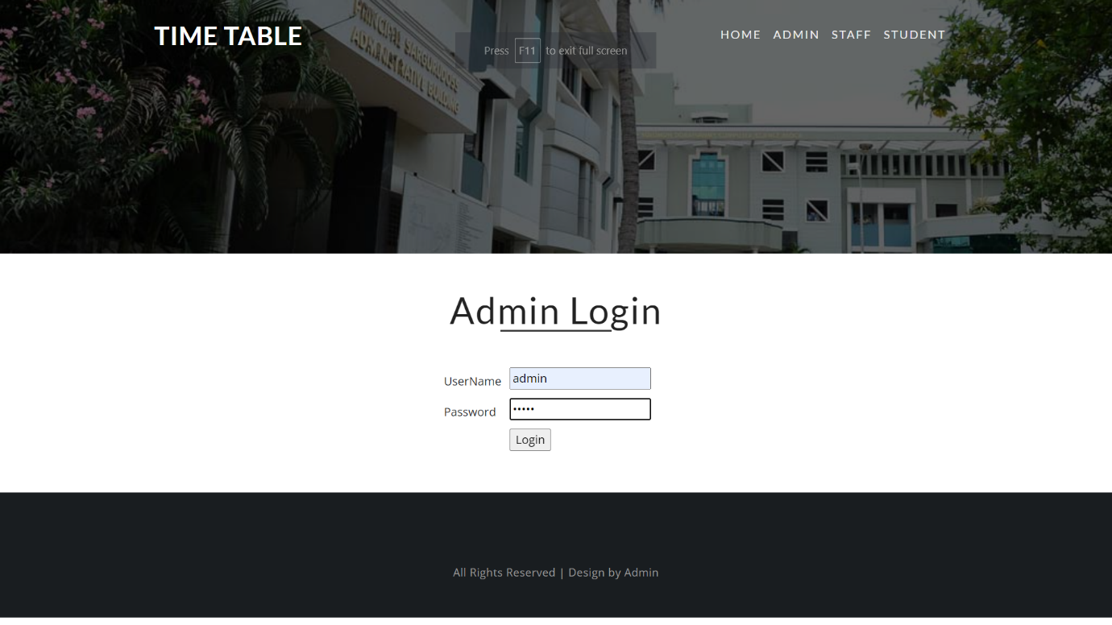**8.2 O/P Screens**

